1. 把烟雾换成白色的，因为垃圾袋中冒出黑烟太奇怪了，而且现在有白边，看起来是premult的问题，先换成白烟试试Change the smoke to white as it's so weird to have black smoke coming out of a bin bag and now it has a white edge, looks like it's a premult problem, try changing it to white smoke first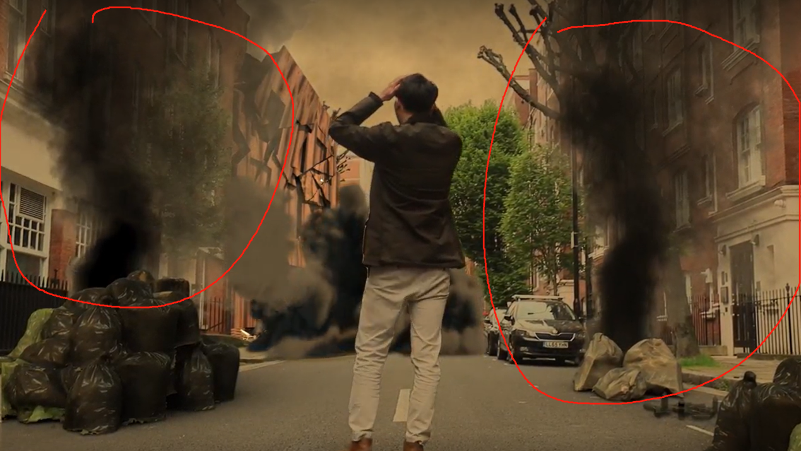
2. 人物周围多次出现白边Multiple white borders around characters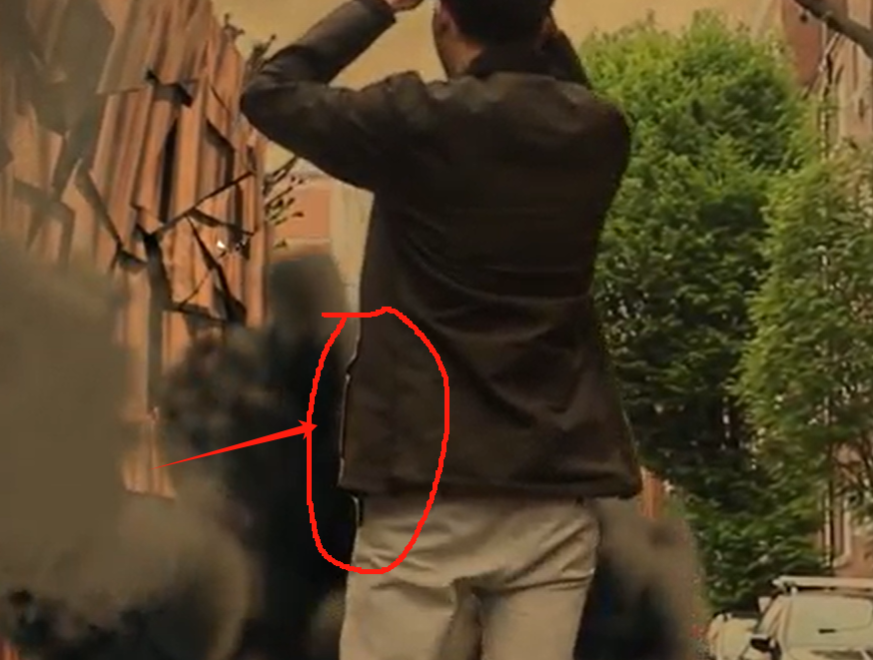
3. 后方的烟雾太假了，是EXR文件本身就是这样的吗？如果是的话现在重新渲染来不及了，做一些颜色合成吧，尽量让这里降低一下饱和度而且是不是这个EXR文件在nuke中被拉伸了？如果拉伸了麻烦把它尽量别让观众发现。The smoke at the back is so fake, is it the EXR file itself that does this? If so it's too late to re-render it now, do some colour compositing, try to get the saturation down a bit here and is it possible that this EXR file is stretched in nuke? If it's stretched could you please make it as unobtrusive as possible to the viewer?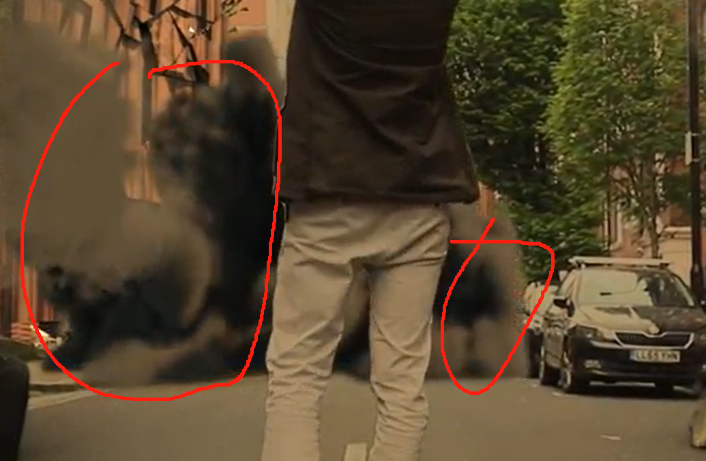
4. 烟雾返回的时候（变成绿色场景）现在太突兀了，我的解决方案是降低烟雾视频的播放速度，并不回放它，让视频在转换为绿色的时候逐步降低它的透明度就可以。The return of the smoke (to a green scene) is now too abrupt, my solution is to slow down the smoke video and not play it back, and just let the video gradually reduce it's transparency as it converts to green.
5. 塑料袋是用AE做的吗？为什么消失的时候是这样的动画？逐渐降低透明度就行，速度别太快 Is the plastic bag made in AE? Why is it animated like this when it disappears? Just gradually reduce the transparency, don't go too fast